Travis Putnam
Chapter Member
Some of us know Travis as a relatively new member, who we do not see very often. But there is a reason. Travis is the President and CEO of the San Diego Youth Leadership Conference. That makes him the President of the Board of Directors. He takes great pride as a 7th and 8th grade History Teacher at the Classic Academy (holding Multiple and Single Subject Credentials). In his spare time Travis is a NJROTC Assistant Instructor at Orange Glen High School (OGHS). This began after being a NJROTC Cadet at OGHS for four years. As a past NJROTC Instructor, I remember Travis as the young college student, who was always helping CDR Jenkins (OGHS Senior Instructor) run one of NJROTC Area – 11’s largest drill Meets.
We are proud to support YLC and the cadets and instructors of Orange Glen High School. Travis is looking for some help from one of our Companions, who would like to be on the SDYLC Board of Directors. He is looking for someone who could find speakers to cover various topics, i.e. Leadership, Business, etc. for the SDYLC. The board meets four times a year, and one or two of those meeting will be online. If If you can help Travis make SDYLC even better than before, please let us know at the next meeting on August 2nd or Nick Herbka at858-254-4905.

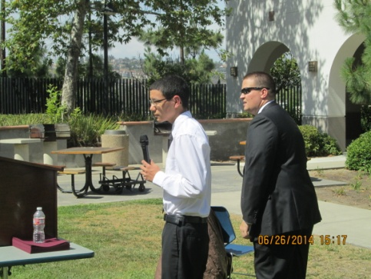 Travis Putnam MC’s the SDYLC Award Ceremony, as a graduate sings the National Anthem.

